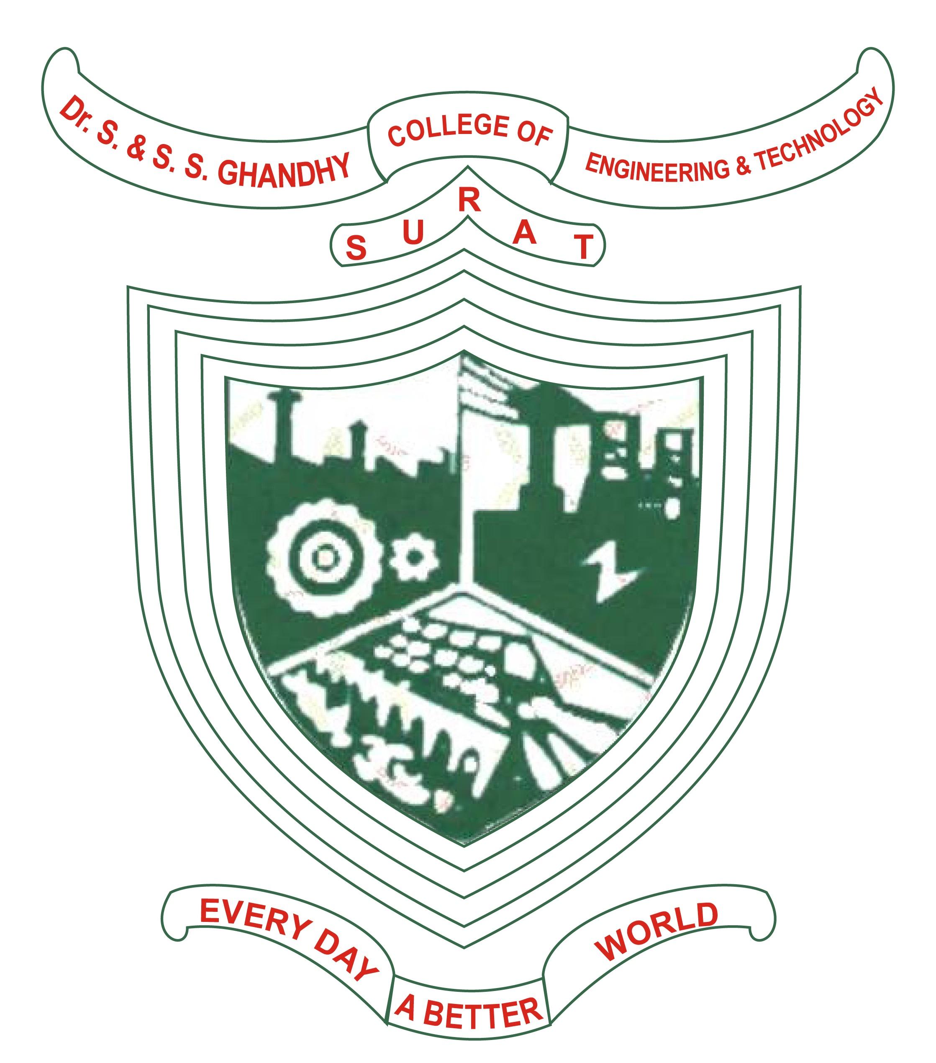
CERTIFICATE

This is to certify that project work embodied in this report entitled “BRTS E-Ticket Management System” was carried out by Arshil Hapani(206120316035), Sanket Sadadiya(206120316038), Vaibhav Sanghani(206120316015) at Dr. S & S. S. Ghandhy College of Engineering & Technology, Surat.

For partial successful completion of Project-II (3361606) of Semester-6 Diploma engineering in Information Technology to be awarded by Gujarat Technological University. This project work has been carried out under my supervision and is to the satisfaction of the department.
Date: 20-05-2023 Place: Surat

Under the supervision of,  Mr. Manish D. Patel  HOD in Information Technology Department  Dr. S. & S. S. Ghandhy College of  Engineering & Technology, Surat | Mr. M. D. Patel  H.O.D., Information Technology Department  Dr. S. & S. S. Ghandhy College of Engineering & Technology, Surat
The Principal  Dr. S. & S. S. Ghandhy College of  Engineering & Technology, Surat | External Examiner

DR. S. & S. S. GHANDHY COLLEGE OF ENGINEERING & TECHNOLOGY
INFORMATION TECHNOLOGY DEPARTMENT
Surat – 395001, Gujarat.

